Name: Krishnaraj Thadesar

Roll Number: 34

Batch: A2

Subject: Computer Networks

Configuring a Simple LAN

Devices:

1. 1 Generic Switch
2. 2 Switch 2960 with 24 LAN ports
3. 6 Generic PCs
4. 4 Laptops

Cables used:

1. Straight LAN Cable to connect unlike devices
2. Crossover LAN Cable to connect like devices

Steps for Configuring the LAN:

1. All 3 switches are connected with each other using crossover cables, as they are similar.
2. 4 PCs are connected to The first Switch
3. 4 Laptops are connected to the Second switch
4. 2 More computers are connected to another Switch.
5. Check the connection by opening the command prompt, and entering the commands ipconfig, and pinging the other computers.

Commands Used:

1. ipconfig

In Windows, ipconfig is a console application designed to run from the Windows command prompt. This utility allows you to get the [IP address information of a Windows computer](https://www.lifewire.com/finding-ip-address-817565). It also allows some control over your network adapters, IP addresses (DHCP-assigned specifically), even your DNS cache. Ipconfig replaced the older winipcfg utility.

1. Ping <ip addr>

The ping command is a [Command Prompt command](https://www.lifewire.com/list-of-command-prompt-commands-4092302) used to test the ability of the source computer to reach a specified destination computer. It's a simple way to verify that a computer can communicate with another computer or network device.

The ping command operates by sending Internet Control Message Protocol (ICMP) Echo Request messages to the destination computer and waiting for a response. The two major pieces of information that the ping command provides are how many of those responses are returned and how long it takes for them to return.

Output of Commands from the Terminal:

FastEthernet0 Connection:(default port)

Link-local IPv6 Address.........: FE80::201:C9FF:FEE6:3985

IP Address......................: 192.168.1.1

Subnet Mask.....................: 255.255.255.0

Default Gateway.................: 0.0.0.0

PC>ping 192.168.1.2

Pinging 192.168.1.2 with 32 bytes of data:

Reply from 192.168.1.2: bytes=32 time=1ms TTL=128

Reply from 192.168.1.2: bytes=32 time=17ms TTL=128

Reply from 192.168.1.2: bytes=32 time=0ms TTL=128

Reply from 192.168.1.2: bytes=32 time=0ms TTL=128

Ping statistics for 192.168.1.2:

Packets: Sent = 4, Received = 4, Lost = 0 (0% loss),

Approximate round trip times in milli-seconds:

Minimum = 0ms, Maximum = 17ms, Average = 4ms

Devices:

|  |  |  |
| --- | --- | --- |
| **Name** | **Type** | **IP** |
| PC0 | PC | 192.168.10.1 |
| PC1 | PC | 192.168.10.2 |
| PC2 | PC | 192.168.10.3 |
| PC3 | PC | 192.168.10.4 |
| PC4 | PC | 192.168.10.5 |
| PC5 | PC | 192.168.10.6 |
| Laptop0 | Laptop | 192.168.10.7 |
| Laptop1 | Laptop | 192.168.10.8 |
| Laptop2 | Laptop | 192.168.10.9 |
| Laptop3 | Laptop | 192.168.10.10 |
| Switch0 | 2950-24 Switch |  |
| Switch1 | 2950-24 Switch |  |
| Switch2 | Generic Switch |  |

Subnet Mask: 255.255.255.0

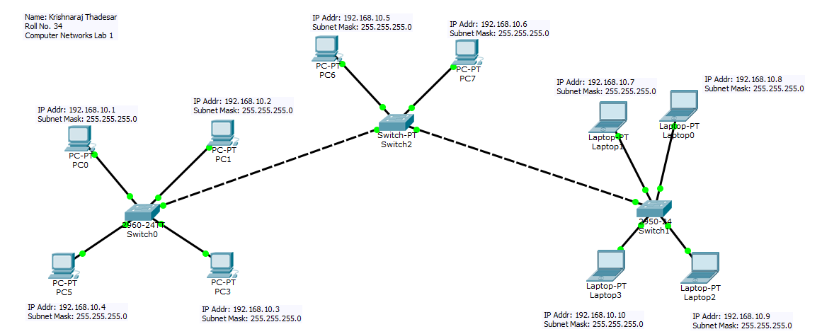LAN Design:

Conclusion:

A local area network was successfully created, deployed and tested on a simulator. The concept behind the Local area network was understood in detail. The various types of cables used to connect the devices were also used and explained. Commands to test computers on a network were also executed successfully. Various computers can be connected with each other and communicate seamlessly with the help of switches, Network Interface Cards, Computers and Straight as well as twisted Ethernet Cables. in a local area network.